***Li-Fi TECHNOLOGY***

***Transmission of data through light***

VAGGU KEERTHI GOUD, VADLA GOWTHAMI

*Department*

*of*

**COMPUTER SCIENCE ENGINEERING**

[**Keerthi.vaggu@gmail.com**](mailto:Keerthi.vaggu@gmail.com)

[**Gowthamiv498@gmail.com**](mailto:Gowthamiv498@gmail.com)





***SREE VISVESVARAYA***

***Institute of Technology & Science***

***Cowderpally MBNR***

**INDEX**

ABSTARCT

1. INTRODUCTION
2. CONSTRUCTION OF LI-FI SYSTEM
3. WORKING OF LI-FI
4. RECENT ADVANCEMENTS IN LI-FI
5. COMPARISON BETWEEN LI-FI & WI-FI

6. APPLICATIONS OF LI-FI

7. EQUIPMENTS

8. CONCLUSION

**ABSTRACT**

Li-Fi stands for Light-Fidelity. Li-Fi technology,proposed by the German physicist—Harald Haas, provides transmission of data through illumination by sending data through an LED light bulb that varies in intensity faster than the human eye can follow. This paper focuses on developing a Li-Fi based system and analyzes its performance with respect to existing technology. Wi-Fi is great for general wireless coverage within buildings, whereas Li-Fi is ideal for high density wireless data coverage in confined area and for relieving radio interference issues. Li-Fi provides better bandwidth, efficiency, availability and security than Wi-Fi and has already achieved blisteringly high speed in the lab. By leveraging the low-cost nature of LEDs and lighting units there are many opportunities to exploit this medium, from public internet access through street lamps to auto-piloted cars that communicate through their headlights. Haas envisions a future where data for laptops, smart phones, and tablets will be transmitted through the light in a room.

1. INTRODUCTION

Transfer of data from one place to another is one of the most important day-to-day activities. The current wireless networks that connect us to the internet are very slow when multiple devices are connected. As the number of devices that access the internet increases, the fixed bandwidth available makes it more and more difficult to enjoy high data transfer rates and connect to a secure network. But, radio waves are just a small part of the spectrum available for data transfer.

A solution to this problem is by the use of Li-Fi. Li-Fi stands for Light-Fidelity. Li-Fi is transmission of data through illumination by taking the fiber out of fiber optics by sending data through an LED light bulb (shown in Fig. 1) that varies in intensity faster than the human eye can follow.

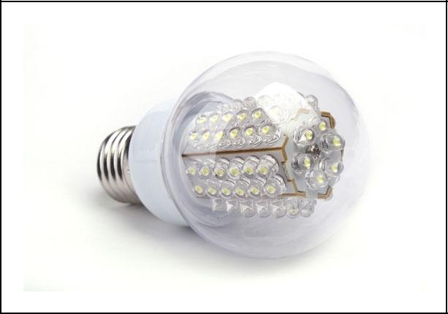Li-Fi is the term some have used to label the fast and cheap wireless communication system, which is the optical version of Wi-Fi. Li-Fi uses visible light instead of Gigahertz radio waves for data transfer.

*Fig. 1. Li-Fi bulb*

The idea of Li-Fi was introduced by a German physicist,, Harald Hass, which he also referred to as ―data through illumination‖. The term Li-Fi was first used by Haas in his TED Global talk on Visible Light Communication. According to Hass, the light, which he referred to as D-Light, can be used to produce data rates higher than 10 megabits per second which is much faster than our average broadband connection .

Li-Fi can play a major role in relieving the heavy loads which the current wireless systems face since it adds a new and unutilized bandwidth of visible light to the currently available radio waves for data transfer. Thus it offers much larger frequency band (300 THz) compared to that available in RF communications (300GHz). Also, more data coming through the visible spectrum could help alleviate concerns that the electromagnetic waves that come with Wi-Fi could adversely affect our health.

Li-Fi can be the technology for the future where data for laptops, smart phones, and tablets will be transmitted through the light in a room. Security would not be an issue because if you can‘t see the light, you can‘t access the data. As a result, it can be used in high security military areas where RF communication is prone to eavesdropping.

|  |  |
| --- | --- |
|  |  |
|  |  |

2. CONSTRUCTION OF LI-FI SYSTEM

Li-Fi is a fast and cheap optical version of Wi-Fi. It is based on Visible Light Communication (VLC).VLC is a data communication medium, which uses visible light between 400 THz (780 nm) and 800 THz (375 nm) as optical carrier for data transmission and illumination. It uses fast pulses of light to transmit information wirelessly. The main components of Li-Fi system are as follows:

1. a high brightness white LED which acts as transmission source.
2. a silicon photodiode with good response to visible light as the receiving element.

LEDs can be switched on and off to generate digital strings of different combination of 1s and 0s. To generate a new data stream, data can be encoded in the light by varying the flickering rate of the LED. The LEDs can be used as a sender or source, by modulating the LED light with the data signal. The LED output appears constant to the human eye by virtue of the fast flickering rate of the LED. Communication rate greater than 100 Mbps is possible by using high speed LEDs with the help of various multiplexing techniques. VLC data rate can be increased by parallel data transmission using an array of LEDs where each LED transmits a different data stream. The Li-Fi emitter system consists of 4 primary sub-assemblies .

1. Bulb
2. RF power amplifier circuit (PA)
3. Printed circuit board (PCB)
4. Enclosure

The PCB controls the electrical inputs and outputs of the lamp and houses the microcontroller used to manage different lamp functions. A RF (radio-frequency) signal is generated by the solid-state PA and is guided into an electric field about the bulb. The high concentration of energy in the electric field vaporizes the contents of the bulb to a plasma state at the bulb‘s center; this controlled plasma generates an intense source of light. All of these subassemblies (shown in Fig. 2) are contained in an aluminum enclosure [10].

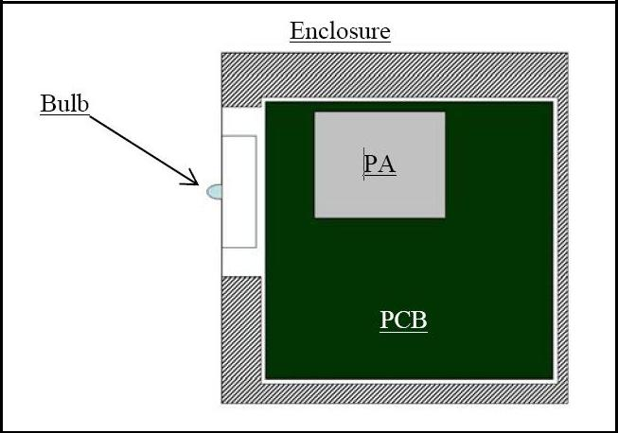

*Fig. 2. Block diagram of Li-Fi sub-assemblies*

The bulb sub-assembly is the heart of the Li-Fi emitter. It consists of a sealed bulb which is embedded in a dielectric material. This design is more reliable than conventional light sources that insert degradable electrodes into the bulb [3]. The dielectric material serves two purposes. It acts as a waveguide for the RF energy transmitted by the PA. It also acts as an electric field concentrator that focuses energy in the bulb. The energy from the electric field rapidly heats the material in the bulb to a plasma state that emits light of high intensity and full spectrum [10]. Figure 3 shows the bulb sub-assembly.

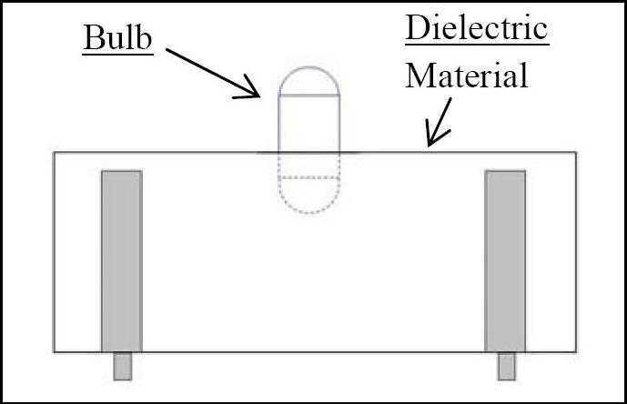

*Fig. 3. Bulb sub-assembly*

There are various inherent advantages of this approach which includes high brightness, excellent color quality and high luminous efficacy of the emitter – in the range of 150 lumens per watt or greater. The structure is mechanically robust without typical degradation and failure mechanisms associated with tungsten electrodes and glass to metal seals, resulting in useful lamp life of 30,000+ hours. In addition, the unique combination of high temperature plasma and digitally controlled solid state electronics results in an economically produced family of lamps scalable in packages from 3,000 to over 100,000 lumens .

3. WORKING OF LI-FI

A new generation of high brightness light-emitting diodes forms the core part of light fidelity technology. The logic is very simple. If the LED is on, a digital 1 is transmitted. If the LED is off, a digital 0 is transmitted. These high brightness LEDs can be switched on and off very quickly which gives us a very nice opportunities for transmitting data through light .

The working of Li-Fi is very simple. There is a light emitter on one end, for example, an LED, and a photo detector (light sensor) on the other. The photo detector registers a binary one when the LED is on; and a binary zero if the LED is off. To build up a message, flash the LED numerous times or use an array of LEDs of perhaps a few different colors, to obtain data rates in the range of hundreds of megabits per second. The block diagram of Li-Fi system is shown in Fig. 4.

|  |  |
| --- | --- |
|  |  |
|  |  |

*Fig. 4. Block diagram of Li-Fi system*

The data can be encoded in the light by varying the flickering rate at which the LEDs flicker on and off to generate different strings of 1s and 0s.The LED intensity is modulated so rapidly that human eye cannot notice, so the light of the LED appears constant to humans .

Light-emitting diodes (commonly referred to as LEDs and found in traffic and street lights, car brake lights, remote control units and countless other applications) can be switched on and off faster than the human eye can detect, causing the light source to appear to be on continuously, even though it is in fact 'flickering'. The on-off activity of the bulb which seems to be invisible enables data transmission using binary codes: switching on an LED is a logical '1', switching it off is a logical '0'. By varying the rate at which the LEDs flicker on and off, information can be encoded in the light to different combinations of 1s and 0s. This method of using rapid pulses of light to transmit information wirelessly is technically referred to as Visible Light Communication (VLC), though it is popularly called as Li-Fi because it can compete with its radio-based rival Wi-Fi. Figure 5 shows a Li-Fi system connecting devices in a room.

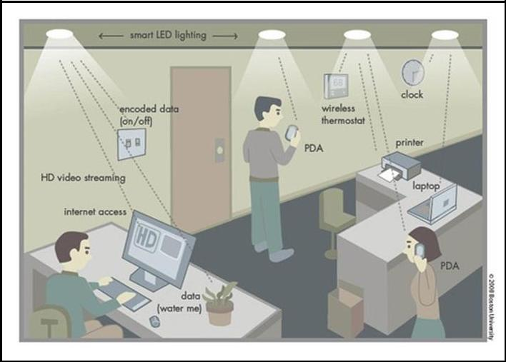

*Fig. 5. Li-Fi system connecting devices in a room*

Many other sophisticated techniques can be used to dramatically increase VLC data rate. Teams at the University of Oxford and the University of Edinburgh are focusing on parallel data transmission using array of LEDs, where each LED transmits a different data stream. Other groups are using mixtures of red, green and blue LEDs to alter the light frequency encoding a different data channel.

4. RECENT ADVANCEMENTS IN LI-FI

Using a standard white-light LED, researchers at the Heinrich Hertz Institute in Berlin, Germany, have reached data rates of over 500 megabytes per second [1]. Using a pair of Casio smart phones, the technology was demonstrated at the 2012 Consumer Electronics Show in Las Vegas to exchange data using light of varying intensity given off from their screens, detectable at a distance of up to ten meters [1]. A consortium called ‗Li-Fi Consortium‘ was formed in October 2011 by a group of companies and industry groups to promote high-speed optical wireless systems and overcome the limited amount of radio based wireless spectrum. According to the Li-Fi Consortium, it is possible to achieve more than 10 Gbps of speed, theoretically which would allow a high-definition film to be downloaded in just 30 seconds . Researchers at the University of Strathclyde in Scotland have begun the task of bringing high-speed, ubiquitous, Li-Fi technology to market .

5. COMPARISON BETWEEN LI-FI & WI-FI

Li-Fi is the name given to describe visible light communication technology applied to obtain high speed wireless communication. It derived this name by virtue of the similarity to Wi-Fi. Wi-Fi works well for general wireless coverage within buildings, and Li-Fi is ideal for high density wireless data coverage inside a confined area or room and for relieving radio interference issues.

Table I shows a comparison of transfer speed of various wireless technologies. Table II shows a comparison of various technologies that are used for connecting to the end user.

Wi-Fi currently offers high data rates. The IEEE 802.11.n in most implementations provides up to 150Mbit/s although practically, very less speed is received.

TABLE I. COMPARISON OF SPEED OF VARIOUS WIRELESS TECHNOLOGIES

|  |  |  |  |  |  |  |  |  |  |  |  |  |
| --- | --- | --- | --- | --- | --- | --- | --- | --- | --- | --- | --- | --- |
|  | | | |  | | | | | | | | |
|  | | | | | | |  |  | | | | |
| **Technology** | | | | | | |  | **Speed** | | | | |
|  | | | | | | |  |  | | | | |
| Wi-Fi – IEEE 802.11n | | | | | | |  | 150 Mbps | | | | |
|  | | | | | | |  |  | | | | |
| Bluetooth | | | | | | |  | 3 Mbps | | | | |
|  | | | |  | | |  |  | | | | |
|  | | | | Ir DA | | |  | 4 Mbps | | | | |
|  | | | |  | | |  |  | | | | |
|  | | | | Li-FI | | |  | >1 Gbps | | | | |
|  | | | |  | | |  |  | | | | |
|  | | | | | | | | | | | | |  | | | |
|  | | | | | | | | | | | | |  | | | |
|  | TABLE II. | | | | COMPARISON OF TECHNOLOGIES USED FOR CONNECTING TO THE END USER | | | | | | | | | | |
|  |  | |  | | | |  |  | | |  |  | |  | |
| **Technology** |  | | **Connection** | | | | **Security** | **Reach** | | | **Impact** | **Cost** | | **Bandwidth Expansion** | |
|  |  | |  | | | |  |  | | |  |  | |  | |
| Wi-Fi |  | | Wireless-  EMF | | | | Good | Excellent | | | unknown | Good | | Limited | |
|  |  | |  | | | |  |  | | |  |  | |  | |
| Hard  wired |  | | Cables | | | | Excellent | Fair | | | None | Good | | Limited | |
|  |  | |  | | | |  |  | | |  |  | |  | |
| Li-Fi |  | | Wireless-  Light | | | | Excellent | Excellent | | | None | Low | | Exceptional | |
|  |  | |  |  | | |  |  | | |  |  | |  | |

1. Problems in Wi-Fi

The following are the basic issues with radio waves:

* 1. **Capacity**: Wireless data is transmitted through radiowaves which are limited and expensive. It has a limited bandwidth. With the rapidly growing world and development of technologies like 3G, 4G and so on we are running out of spectrum.
  2. **Efficiency**: There are 1.4 million cellular radio basestations that consume massive amount of energy. Most of the energy is used for cooling down the base station instead of transmission. Therefore efficiency of such base stations is only 5%.
  3. **Availability**: Availability of radio waves is a bigconcern. It is not advisable to use mobile phones in aero planes and at places like petrochemical plants and petrol pumps.
  4. **Security**: Radio waves can penetrate through walls.They can be intercepted. If someone has knowledge and bad intentions, they may misuse it. This causes a major security concern for Wi-Fi.

1. Advantages of Li-Fi

Li-Fi technology is based on LEDs or other light source for the transfer of data. The transfer of the data can be with the help of all kinds of light, no matter the part of the spectrum that they belong. That is, the light can belong to the invisible, ultraviolet or the visible part of the spectrum. Also, the speed of the communication is more than sufficient for downloading movies, games, music and all in very less time.

Also, Li-Fi removes the limitations that have been put on the user by the Wi-Fi.

1. **Capacity**: Light has 10000 times wider bandwidththan radio waves [5]. Also, light sources are already installed. So, Li-Fi has got better capacity and also the equipments are already available.
2. **Efficiency**: Data transmission using Li-Fi is verycheap. LED lights consume less energy and are highly efficient.
3. **Availability**: Availability is not an issue as lightsources are present everywhere. There are billions of light bulbs worldwide; they just need to be replaced with LEDs for proper transmission of data.
4. **Security**: Light waves do not penetrate through walls.

So, they can‘t be intercepted and misused.

With the advent of Li-Fi, now it is not mandatory to be in a region that is Wi-Fi enabled to have access to the internet. One can simply stand under any form of light and surf the internet as the connection is made if light is present. Figure 6 gives a description of Li-Fi along with its advantages.

C. Disadvantages of LiFi

One of the major demerits of this technology is that the artificial light cannot penetrate into walls and other opaque materials which radio waves can do. So a Li-Fi enabled end device (through its inbuilt photo-receiver) will never be as fast and handy as a Wi-Fi enabled device in the open air. Also, another shortcoming is that it only works in direct line of sight.

Still, Li-Fi could emerge as a boon to the rapidly depleting bandwidth of radio waves. And it will certainly be the first choice for accessing internet in a confined room at cheaper cost.

6. APPLICATIONS OF LI-FI

There are numerous applications of this technology, from public internet access through street lamps to auto-piloted cars that communicate through their headlights.

Applications of Li-Fi can extend in areas where the Wi-Fi technology lacks its presence like medical technology, power plants and various other areas. Since Li-Fi uses just the light, it can be used safely in aircrafts and hospitals where Wi-Fi is banned because they are prone to interfere with the radio waves.

All the street lamps can be transferred to Li-Fi lamps to transfer data. As a result of it, it will be possible to access internet at any public place and street.

Some of the future applications of Li-Fi are as follows:

1. **Education systems:** Li-Fi is the latest technology thatcan provide fastest speed internet access. So, it can replace Wi-Fi at educational institutions and at companies so that all the people can make use of Li-Fi with the same speed intended in a particular area.

|  |  |
| --- | --- |
| **Medical Applications:** Operation theatres (OTs) donot allow Wi-Fi due to radiation concerns. Usage of Wi-Fi at hospitals interferes with the mobile and pc which blocks the signals for monitoring equipments. So, it may be hazardous to the patient's health. To overcome this and to make OT tech savvy Li-Fi can be used to accessing internet and to control medical |  |
|  |  |

7. EQUIPMENTS

This can even be beneficial for robotic surgeries and other automated procedures.

1. **Cheaper Internet in Aircrafts:** The passengerstravelling in aircrafts get access to low speed internet at a very high rate. Also Wi-Fi is not used because it may interfere with the navigational systems of the pilots. In aircrafts Li-Fi can be used for data transmission. Li-Fi can easily provide high speed internet via every light source such as overhead reading bulb, etc. present inside the airplane.
2. **Underwater applications:** Underwater ROVs(Remotely Operated Vehicles) operate from large cables that supply their power and allow them to receive signals from their pilots above. But the tether used in ROVs is not long enough to allow them to explore larger areas. If their wires were replaced with light — say from a submerged, high-powered lamp then they would be much freer to explore. They could also use their headlamps to communicate with each other, processing data autonomously and sending their findings periodically back to the surface . Li-Fi can even work underwater where Wi-Fi fails completely, thereby throwing open endless opportunities for military operations.
3. **Disaster management:** Li-Fi can be used as apowerful means of communication in times of disaster such as earthquake or hurricanes. The average people may not know the protocols during such disasters. Subway stations and tunnels, common dead zones for most emergency communications, pose no obstruction for Li-Fi [1]. Also, for normal periods, Li-Fi bulbs could provide cheap high-speed Web access to every street corner.
4. **Applications in sensitive areas:** Power plants needfast, inter-connected data systems so that demand, grid integrity and core temperature (in case of nuclear power plants) can be monitored. Wi-Fi and many other radiation types are bad for sensitive areas surrounding the power plants. Li-Fi could offer safe, abundant connectivity for all areas of these sensitive locations. This can save money as compared to the currently implemented solutions. Also, the pressure on a power plant‘s own reserves could be lessened. Li-Fi can also be used in petroleum or chemical plants where other transmission or frequencies could be hazardous.
5. **Traffic management:** In traffic signals Li-Fi can beused which will communicate with the LED lights of the cars which can help in managing the traffic in a better manner and the accident numbers can be decreased [1]. Also, LED car lights can alert drivers when other vehicles are too close.
6. **Replacement for other technologies:** Li-Fi doesn‘twork using radio waves. So, it can be easily used in the places where Bluetooth, infrared, Wi-Fi, etc. are banned

.

8. CONCLUSION

There are a plethora of possibilities to be gouged upon in this field of technology. If this technology becomes justifiably marketed then every bulb can be used analogous to a Wi-Fi hotspot to transmit data wirelessly. By virtue of this we can ameliorate to a greener, cleaner, safer and a resplendent future. The concept of Li-Fi is attracting a lot of eye-balls because it offers a genuine and very efficient alternative to radio based wireless. It has a bright chance to replace the traditional Wi-Fi because as an ever increasing population is using wireless internet, the airwaves are becoming increasingly clogged, making it more and more difficult to get a reliable, high-speed signal. This concept promises to solve issues such as the shortage of radio-frequency bandwidth and boot out the disadvantages of Wi-Fi. Li-Fi is the upcoming and on growing technology acting as competent for various other developing and already invented technologies. Hence the future applications of the Li-Fi can be predicted and extended to different platforms and various walks of human life.

9.ACKNOWLEDGEMENT

We would like to acknowledge the contribution of all the people who have helped in reviewing this paper. We would like to give sincere thanks to Mrs. Sandhya Pati for her guidance and support throughout this paper. We would also like to thank our families and friends who supported us in the course of writing this paper.

REFERENCES

1. Jyoti Rani, PrernaChauhan, RitikaTripathi, ―Li-Fi (Light Fidelity)-The future technology In Wireless communication‖, International Journal of Applied Engineering Research, ISSN 0973-4562 Vol.7 No.11 (2012).
2. Richard Gilliard, Luxim Corporation, ―The lifi® lamp high efficiency high brightness light emitting plasma with long life and excellent color quality‖.
3. Richard P. Gilliard, Marc DeVincentis, AbdeslamHafidi, Daniel O‘Hare, and Gregg Hollingsworth, ―Operation of the LiFi Light Emitting Plasma in Resonant Cavity‖.
4. Visilink, ―Visible Light Communication Technology for Near‐Ubiquitous Networking‖ White Paper, January 2012.
5. http://edition.cnn.com/2012/09/28/tech/lifi-haas-innovation
6. http://articles.economictimes.indiatimes.com/2013-01-14/news/36331676_1_data-transmission-traffic-signals-visible-light-spectrum
7. http://www.extremetech.com/extreme/147339-micro-led-lifi-where-every-light-source-in-the-world-is-also-tv-and-provides-gigabit-internet-access
8. http://www.dvice.com/archives/2012/08/lifi-ten-ways-i.php
9. http://www.good.is/posts/forget-wifi-it-s-lifi-internet-through-lightbulbs
10. http://www.lifi.com/pdfs/techbriefhowlifiworks.pdf
11. <http://www.ispreview.co.uk/index.php/2013/01/tiny-led-lights-set-to-deliver-wifi-> style-internet-communications.html
12. http://www.newscientist.com/article/mg21128225.400-will-lifi-be-the-new-wifi.html
13. http://groupivsemi.com/working-lifi-could-be-available-soon/

|  |  |
| --- | --- |
|  |  |
|  |  |